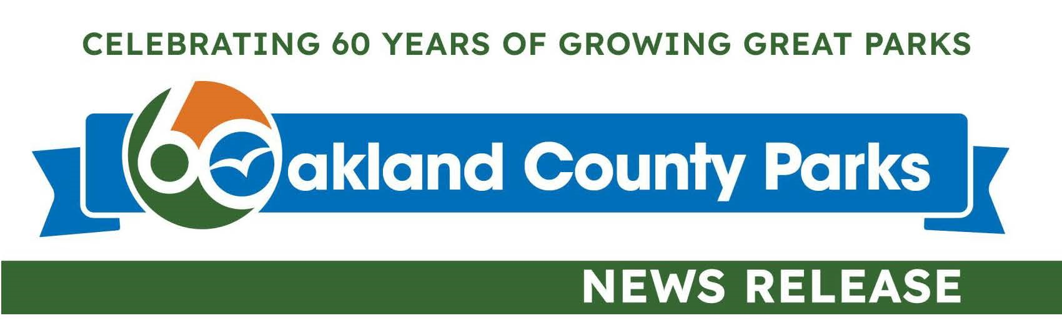

Desiree Stanfield
Chief Marketing and Communications
248-705-4108 | stanfieldd@oakgov.com

Oakland County Parks celebrates 60 years of community connection
Special activities planned to mark long history of recreation, nature and wellness opportunities

OAKLAND COUNTY, MI – Feb. 19, 2026 – Oakland County Parks (OCP) is commemorating its 60th anniversary, honoring its decades-long commitment of preserving natural areas, enhancing outdoor community spaces and offering unique recreation programming for individuals of all ages and abilities. These activities have greatly contributed to the high quality of life throughout Oakland County and set the bar high for the future of public recreation.

“For 60 years, OCP has been enriching the lives of residents and we plan to continue to do so for generations to come,” Parks Director Chris Ward said. “The parks system continues to grow and flourish with new partnerships, providing all residents with opportunities to connect with nature and boost their mental and physical health close to home. This anniversary commemorates OCP’s substantial impact as an essential community resource.”

At its Feb. 19 board meeting, the Oakland County Board of Commissioners approved a proclamation recognizing the 60th anniversary and honoring the Oakland County Parks and Recreation Commission (OCPRC) for its work throughout the years.

“For 60 years, Oakland County Parks has shown what’s possible when we invest in shared spaces that serve everyone. Our parks are more than destinations, they’re essential infrastructure for health, equity and community connection. As we mark this milestone, we remain focused on building a future where all residents in Oakland County across generations can feel like they belong,” OCPRC Chair Ebony Bagley said.

A look back
The parks system was established in 1966, 40 years after Manley Davis donated 169 acres of his family’s homestead in Davisburg for the creation of a county-owned park. At the time, no funding mechanism existed for county-owned parks without special legislation, but that changed with the passage of Michigan’s Public Act 261 of 1965. Hoping to preserve green spaces from rapid urban growth, it allowed for the creation of county and regional park systems under the direction of Park and Recreation Commissions.

Shortly after, the Davisburg Park Golf Course that had been operating on the Manley property under the Oakland County Road Commission was transferred to the newly formed Oakland County Parks and Recreation Commission. This is the site where Springfield Oaks County Park continues to operate today.

Following voter approval of a park millage, more property was acquired for recreation purposes. Waterford Oaks County Park, formerly the site of the Evangelical Mission Church and campground, was purchased in 1967. The 197-acre Paradise Campground and Beach was purchased and renamed Groveland Oaks County Park in 1968. The 700-acre Tudor Hills Gun Club and Game Preserve in Leonard was purchased and renamed Addison Oaks County Park. In 1969, OCPRC purchased 337 acres from the Brock and Pew families to establish Independence Oaks County Park. The purchase of White Lake Oaks Golf Course came in 1970. Today, the parks system features more than 7,000 acres and 17 parks.

“The land we steward tells the story of Oakland County’s history,” OCP Historian Carol Bacak-Egbo said. “Many of our parks preserve farmlands, waterways and even old forests that are remnants of the county’s past. Our 60th anniversary offers an important opportunity to learn more about how these lands were established for public use and how those who came before us helped shape who we are as a community today.”

Significant milestones
Over the decades, OCP has redefined outdoor recreation, reaching significant milestones such as:
- Opening Michigan's first waterpark at Waterford Oaks in 1976. The outdoor facility featured a wave pool and giant double waterslide and was the second municipally-owned wave pool in the United States.
- Building a bicycle motocross (BMX) track from soil excavated for the Waterford Oaks wave pool. Throughout its history, the track has hosted a world championship and numerous national events. It continues to thrive today.
- Achieving a Catch-and-Release-Only Special Designation for Upper Bushman Lake at Independence Oaks-North Nature Park. It is the first and only public access lake in Southeast Michigan with this designation.
- Opening Holly Oaks ORV Park, a year-round adventure destination open to all types of ORVs, in 2020. Consisting of former and active sand and gravel mines, the park is a joint state-county project operated by Oakland County Parks in a partnership with the Michigan Department of Natural Resources.
- Partnering with the City of Pontiac on Pontiac Oaks Park. Oakland County Parks is investing more than $1.5 million to improve park facilities and has assumed long-term responsibility for park management and maintenance while the City of Pontiac retains ownership of the property.
Anniversary activities
To commemorate the anniversary, three honorary ambassadors have been named: Nancy Quarles, J. David VanderVeen and Sue Wells. All have been instrumental in the growing the parks system and creating a solid foundation for success.

Quarles, a former Oakland County Board of Commissioners Member and OCPRC Commissioner, believes that parks should be viewed as much more than patches of green.

“Our parks offer welcoming spaces for walking, cycling and team sports, helping keep our families healthy and active,” she said. “Oakland County remains deeply committed to the beauty and utility of these shared spaces. Our ongoing dedication to the park system ensures that these natural treasures remain clean, safe and modern for everyone to enjoy. By prioritizing the care and expansion of our trails and parks, the county isn’t just maintaining land - it is investing in the long-term health and happiness of our residents, both today and for generations to come.”

VanderVeen stated that Oakland County is blessed with natural beauty in the form of lakes, rivers, forests, fields and hills.

“The Parks Commission and staff work diligently to preserve our natural resources and create recreation opportunities. These outdoors spaces make an incredibly significant contribution to our quality of life,” said the former OCPRC Vice Chair.

Wells, former Manager – Operations Oakland County Parks, said she’s proud that OCP has preserved land for current and future generations, creating regional facilities and programs used by millions over the last 60 years.

“As manager of operations, I saw firsthand that residents are fortunate to have dedicated staff who want to make a difference in people’s lives. They want our residents to have the best opportunities for recreation outdoors,” she said.

The parks system will also host several specially themed events for the public to enjoy, including a Birthday Bash in July, historical programming and historical exhibits. Details and updates will be available at OaklandCountyParks.com throughout the year.

OCP’s popular mascot, Oakie the Squirrel, also will be making appearances throughout local communities wearing his special anniversary-themed apparel. Residents are encouraged to join the celebration and share their favorite park memories at Facebook.com/OCParks.

Looking ahead
Today, OCP is focused on its mission to provide equitable access, conservation, recreation and health and wellness benefits, ensuring parks continue to meet the evolving needs of the communities it serves. Nearly 2 million guests visit the parks each year and many more attend events, festivals and other activities where OCP provides mobile recreation units, nature education and additional opportunities.

As it looks to the future, Oakland County Parks remains committed to preserving environmental resources, protecting natural landscapes and ensuring that parks continue to serve as places for recreation, wellness and community connection.

Key statistics
- 73 percent of Oakland County residents will live within three miles of a county-funded park by 2030
- 560 acres were added to the parks system through partnerships in 2025
- An additional 640 acres are subject to proposed partnerships
More information about anniversary events and the history of the county parks system is available at OaklandCountyParks.com.

####

Link to the Oakland County Parks 60th Anniversary logo to be used in accordance with OCP’s brand standards: https://www.oakgov.com/community/oakland-county-parks/media

Historical and current park photos as well as headshots of the honorary ambassadors are available upon request.

