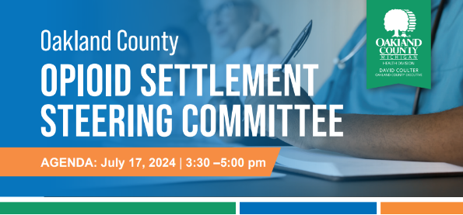
Oakland County

OPIOID SETTLEMENT STEERING COMMITTEE
July 15, 2025 | 3:30 – 5:00 pm
September 17, 2024 | 3:30 – 5:00 pm
AGENDA: August 20, 2024 | 3:30 –5:00 pm
Agenda
- Welcome and icebreaker (3:30-3:40)
- OFR data update and progress highlights (3:40-3:50)
- Updates on funded items and RFI finalization (3:50-4:00)
- Overview of Oakland Connects (4:00-4:30)
- Discussion on steering committee future directions (4:30-4:55)
- Next steps (4:55-5:00)
Objectives
- Review updated Overdose Fatality Review (OFR) data and recent progress related to recommendations
- Gain an understanding of services and resources provided at the county level through Oakland Connects
- Receive updates on funded items and the current status of Requestion for Information (RFI) finalization and release
- Engage in discussion regarding the steering committee’s future directions and ongoing role

